St Gregory’s Catholic Primary School
‘Loving and Learning’
The St Gregory’s Curriculum
Music
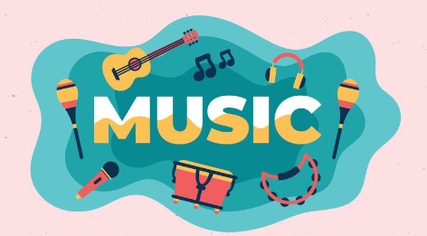
“We are a single family, dwelling in a common home.” Pope Francis, Fratelli Tutti, 17
‘The Levites stood near the east side of the altar with cymbals and harps, and with them were 120 priests playing trumpets. The singers were accompanied in perfect harmony by trumpets, cymbals, and other instruments, as they praised the LORD, singing:
“Praise the LORD, because he is good, And his love is eternal.” ’ 2 Chronicles 5
Catholic Social Teaching
Participation.
Catholic School Pupil Profile
Active. Faith-filled.
Curriculum Intent for Music
Music is a universal language that embodies one of the highest forms of creativity. Our music education is high-quality and engages and inspires the pupils to develop a love of music and their talent as musicians. We intend to provide opportunities for children to enjoy learning about music in all its forms. We want pupils to explore making music, listening, appreciating it and recognising its language, patterns and notations. Children will have the opportunities to perform together and embrace their talents as musicians, increasing their confidence, creativity and sense of achievement. Pupils will be exposed to a range of music from various historical periods, genres, styles, traditions and the works of great composers and musicians.
Pupils are given opportunities to learn musical instruments and perform as a solo musician or part of a group. They will develop their confidence to perform and express themselves through singing and playing. Our music curriculum helps foster a love of music and key vocabulary is progressively taught from KS1 to KS2. Music also underpins collective worship throughout the school and is key to the catholicity of St. Gregory’s.

Curriculum Implementation for Music
Our curriculum is centred around ‘Charanga’, a music-based scheme, in which children learn to sing, play instruments and perform. The scheme of work covers the National Curriculum strands for music and from EYFS to KS2, pupils will become well-rounded musicians. Throughout weekly lessons, children are given opportunities to develop an understanding of pulse, rhythm and notation. It is delivered by class teachers using a clearly planned and sequential, rich syllabus. This is further enhanced through regular opportunities for singing collectively such as collective worship, performances and concerts.
Each unit exposes pupils to a wide variety of genres and each lesson follows a clear sequence of learning. Listening and appraise, interrelated dimensions of music, singing, playing instruments, improvisation, composition, perform and share. This approach creates confident musicians through fun and interactive lessons. Pupils from EYFS are exposed to key musical vocabulary, various composers and artists which are also encouraged through collective worship as a whole school.
Curriculum Impact for Music
As a result of our exciting music curriculum at St. Gregory’s, pupils will have opportunities to listen to, engage with and develop an appreciation for music. They will learn to play tuned and un-tuned instruments through lessons and extra-curricular music activities. The children will recognise a wide range of genres and participate in games to solidify their knowledge. Every week, pupils will consolidate previous learning and understand the significance and place of music within the wider world.
Pupils will be given continuous opportunities to perform pieces of music through singing or playing instruments half termly. ‘Performance Assemblies’ will increase the children’s confidence when performing and in turn they will be inspired to participate in Christmas performances and concerts for the wider community. Collective worship regularly includes singing for the children which fosters our love for music as a school.

